ERT303 PLC 1
Final Project

Airport Goods Sorting System

Submitted To Prof. Al Douglas, P.Eng.
Electromechanical Engineering Technician – Robotics

12/12/2024

Dhruv Maheshbhai Patel 0859886

Table Of Contents
Contents
Table Of Contents 2
Table Of Figures 2
Project Concept 3
Sequence of Operations 4
Tags (Real Devices Only) 4
Logic Screen Shots 5
Table Of Figures
Figure 1 - view the entire station with red arrow showing direction of part flow 3
Figure 2 - Table of used tags 4
Figure 3 - Logic page 1 5
Figure 4 - Logic Page 2 6

Project Concept

This machine first displays the weight of parts as they travel down a conveyor belt and then it gets sort, based on color to its respective station. The machine consiste of:
- a weigh scale (analog input)
- the bunch of conveyor belt
- three Pivot Arms
- a part emitter and two removers
- panel with start, stop and emergency stop control of the conveyors
- panel with two reset buttons for lighting
- a numeric display of the actual weight in kg
- two numeric displays for math functions
- A diffuse sensor to temporarily stop the part of the weight scale
- Two diffuse sensors for calculating fragile parts
- Four vision sensors to give input based on parts
- The bunch of stacklight at front and each station
- Some warning lights
- A safety door
- Bunch of fences according to safety standard
- A platform to collect fragile parts
- Alarm Siren at each station
- Staircase goes on other side and inspects system functions.
- Some aligners and wheels to align goods in path

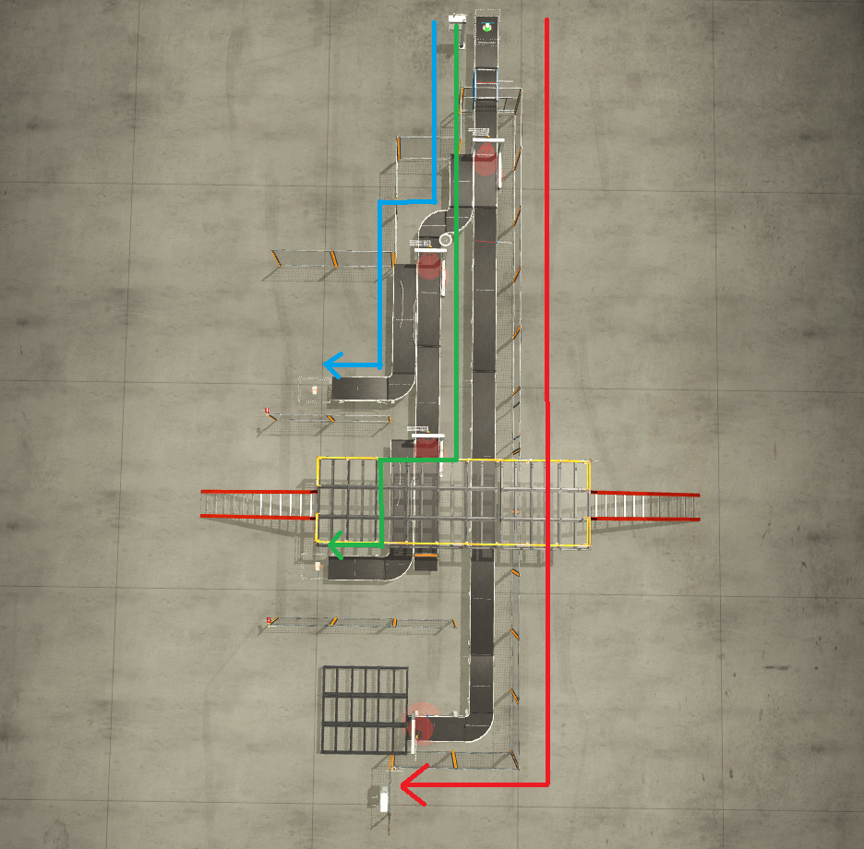
Figure 1 - view the entire station with red arrow showing direction of Fragile goods towards its station.

Sequence of Operations

- Start stop control of the conveyor makes the conveyor belt, the weight scale belt and pivot arm belt runs
- Tri color parts and metal cap are generated by emitter
- At first, Part travels down the belt onto the weight scale
- Once detected by the diffuse sensor, the belts stop until a 5 second delay elapses. This time delay allows for a more accurate weight measurement
- The weight is read and the signal is converted from raw analog 0-10 to 0-30 kg via math instructions
- The final true weight is sent to the numeric weight display
- Once the part exits the scale, it is detected by vision sensor.
- Then vision sensor gives command to pivot arm according to our program.
- According to our program, Metal base and cap must go straight as shown in red path in Fig 1.
- Blue part and green part are sorted from main line and directed towards individual station.

Tags (Real Devices Only)

Count | Factory IO Device Name | Factory IO  Device Type | Linked Tag  Name In factory IO | Tag Created In PLC | PLC Tag Type | PLC Tag Alias
1 | Emergency Stop 0 | BOOL | BOOL_IN_1 | BOOL_IN_1 | BOOL | EmergencyStop
2 | Start Button 0 | BOOL | BOOL_IN_2 | BOOL_IN_2 | BOOL | StartPB
3 | Stop Button 0 | BOOL | BOOL_IN_3 | BOOL_IN_3 | BOOL | StopPB
4 | WEIGHT SENSOR | BOOL | BOOL_IN_4 | BOOL_IN_4 | BOOL | WeightSensor
5 | FRAGILE SENSOR | BOOL | BOOL_IN_5 | BOOL_IN_5 | BOOL | FRAGILESENSOR
6 | Vision Sensor 1(0) | BOOL | BOOL_IN_6 | BOOL_IN_6 | BOOL | VISION1A
7 | Vision Sensor 1(1) | BOOL | BOOL_IN_7 | BOOL_IN_7 | BOOL | VISION1B
8 | Vision Sensor 1(2) | BOOL | BOOL_IN_8 | BOOL_IN_8 | BOOL | VISION1C
9 | Vision Sensor 2(0) | BOOL | BOOL_IN_9 | BOOL_IN_9 | BOOL | VISION2A
10 | Vision Sensor 2(1) | BOOL | BOOL_IN_10 | BOOL_IN_10 | BOOL | VISION2B
11 | Vision Sensor 2(2) | BOOL | BOOL_IN_11 | BOOL_IN_11 | BOOL | VISION2C
12 | Vision Sensor 3(0) | BOOL | BOOL_IN_12 | BOOL_IN_12 | BOOL | VISION3A
13 | Vision Sensor 3(1) | BOOL | BOOL_IN_13 | BOOL_IN_13 | BOOL | VISION3B
14 | Vision Sensor 3(2) | BOOL | BOOL_IN_14 | BOOL_IN_14 | BOOL | VISION3C
15 | Vision Sensor 3(3) | BOOL | BOOL_IN_15 | BOOL_IN_15 | BOOL | VISION3D
16 | Reset Button 0 | BOOL | BOOL_IN_16 | BOOL_IN_16 | BOOL | PBRESET1
17 | Reset Button 1 | BOOL | BOOL_IN_17 | BOOL_IN_17 | BOOL | PBRESET2
18 | Safety Door 1 | BOOL | BOOL_IN_18 | BOOL_IN_18 | BOOL | SAFTEYDOOR
19 | Vision Sensor 4(0) | BOOL | BOOL_IN_19 | BOOL_IN_19 | BOOL | VISION4A
20 | Vision Sensor 4(1) | BOOL | BOOL_IN_20 | BOOL_IN_20 | BOOL | VISION4B
21 | Vision Sensor 4(2) | BOOL | BOOL_IN_21 | BOOL_IN_21 | BOOL | VISION4C

Figure 2 - Table of used tags
22 | Vision Sensor 4(3) | BOOL | BOOL_IN_22 | BOOL_IN_22 | BOOL | VISION4D
23 | FRAGILE Sensor 2 | BOOL | BOOL_IN_23 | BOOL_IN_23 | BOOL | FRAGILESENSOR2
1 | Conveyor Scale 0 Weight(V) | FLOAT | FLOAT_IN_1 | FLOAT_IN_1 | REAL | WeightScale
1 | Belt Conveyor(2m) 0 | BOOL | BOOL_OUT_1 | BOOL_OUT_1 | BOOL | BELT0
2 | Belt Conveyor(2m) 1 | BOOL | BOOL_OUT_2 | BOOL_OUT_2 | BOOL | BELT1
3 | Belt Conveyor(2m) 2 | BOOL | BOOL_OUT_3 | BOOL_OUT_3 | BOOL | BELT2
4 | Belt Conveyor(2m) 3 | BOOL | BOOL_OUT_4 | BOOL_OUT_4 | BOOL | BELT3
5 | Belt Conveyor(2m) 4 | BOOL | BOOL_OUT_5 | BOOL_OUT_5 | BOOL | BELT4
6 | Belt Conveyor(2m) 5 | BOOL | BOOL_OUT_6 | BOOL_OUT_6 | BOOL | BELT5
7 | Belt Conveyor(4m) 0 | BOOL | BOOL_OUT_7 | BOOL_OUT_7 | BOOL | BELT6
8 | Belt Conveyor(4m) 1 | BOOL | BOOL_OUT_8 | BOOL_OUT_8 | BOOL | BELT7
9 | Belt Conveyor(4m) 2 | BOOL | BOOL_OUT_9 | BOOL_OUT_9 | BOOL | BELT8
10 | Belt Conveyor(4m) 3 | BOOL | BOOL_OUT_10 | BOOL_OUT_10 | BOOL | BELT9
11 | Belt Conveyor(4m) 4 | BOOL | BOOL_OUT_11 | BOOL_OUT_11 | BOOL | BELT10
12 | Belt Conveyor(4m) 5 | BOOL | BOOL_OUT_12 | BOOL_OUT_12 | BOOL | BELT11
13 | Belt Conveyor(4m) 6 | BOOL | BOOL_OUT_13 | BOOL_OUT_13 | BOOL | BELT12
14 | Belt Conveyor(6m) 0 | BOOL | BOOL_OUT_14 | BOOL_OUT_14 | BOOL | BELT13
15 | Belt Conveyor(6m) 1 | BOOL | BOOL_OUT_15 | BOOL_OUT_15 | BOOL | BELT14
16 | Conveyor Scale 0 (+) | BOOL | BOOL_OUT_16 | BOOL_OUT_16 | BOOL | BELTWEIGHTSCALE
17 | Alarm Siren 0 | BOOL | BOOL_OUT_17 | BOOL_OUT_17 | BOOL | AlarmSta1
18 | Curved Belt Conveyor 0 CW | BOOL | BOOL_OUT_18 | BOOL_OUT_18 | BOOL | CURVEBELT0
19 | Curved Belt Conveyor 2 CW | BOOL | BOOL_OUT_19 | BOOL_OUT_19 | BOOL | CURVEBELT2
20 | Curved Belt Conveyor 3 CW | BOOL | BOOL_OUT_20 | BOOL_OUT_20 | BOOL | CURVEBELT3
21 | Curved Belt Conveyor 4 CW | BOOL | BOOL_OUT_21 | BOOL_OUT_21 | BOOL | CURVEBELT4
22 | Curved Belt Conveyor 1 CCW | BOOL | BOOL_OUT_22 | BOOL_OUT_22 | BOOL | CURVEBELT1
23 | Pivot Arm Sorter 0 Turn | BOOL | BOOL_OUT_23 | BOOL_OUT_23 | BOOL | PIVOTARM0
24 | Pivot Arm Sorter 1 Turn | BOOL | BOOL_OUT_24 | BOOL_OUT_24 | BOOL | PIVOTARM1
25 | Pivot Arm Sorter 2 Turn | BOOL | BOOL_OUT_25 | BOOL_OUT_25 | BOOL | PIVOTARM2
26 | Pivot Arm Sorter 0 Belt (+) | BOOL | BOOL_OUT_26 | BOOL_OUT_26 | BOOL | PIVOTARMBELT0
27 | Pivot Arm Sorter 1 Belt (+) | BOOL | BOOL_OUT_27 | BOOL_OUT_27 | BOOL | PIVOTARMBELT1
28 | Pivot Arm Sorter 2 Belt (+) | BOOL | BOOL_OUT_28 | BOOL_OUT_28 | BOOL | PIVOTARMBELT2
29 | Part on Fragile Station 1 (Red) | BOOL | BOOL_OUT_29 | BOOL_OUT_29 | BOOL | STACKLTRED1
30 | Conveyor Running 1 (Green) | BOOL | BOOL_OUT_30 | BOOL_OUT_30 | BOOL | STACKLTGREEN1
31 | Fragile part on line 1 (yellow) | BOOL | BOOL_OUT_31 | BOOL_OUT_31 | BOOL | STACKLTYELLOW1
32 | Alarm Siren 1 | BOOL | BOOL_OUT_32 | BOOL_OUT_32 | BOOL | AlarmSta2
33 | Start Button 0 (Light) | BOOL | BOOL_OUT_33 | BOOL_OUT_33 | BOOL | STARTLT
34 | Stop Button 0 (Light) | BOOL | BOOL_OUT_34 | BOOL_OUT_34 | BOOL | STOPLT
35 | Overweight (Red) | BOOL | BOOL_OUT_35 | BOOL_OUT_35 | BOOL | STACKLTRED
36 | Conveyor Running (Green) | BOOL | BOOL_OUT_36 | BOOL_OUT_36 | BOOL | STACKLTGREEN
37 | Fragile Line Active (Yellow) | BOOL | BOOL_OUT_37 | BOOL_OUT_37 | BOOL | STACKLTYELLOW
38 | Fragile Line Active 0 | BOOL | BOOL_OUT_38 | BOOL_OUT_38 | BOOL | WARNLTSTAIR
39 | Fragile Line Active 1 | BOOL | BOOL_OUT_39 | BOOL_OUT_39 | BOOL | WARNLTST1
40 | Part on Fragile Station (Red) | BOOL | BOOL_OUT_40 | BOOL_OUT_40 | BOOL | STACKLTRED2
41 | Conveyor Running (Green) | BOOL | BOOL_OUT_41 | BOOL_OUT_41 | BOOL | STACKLTGREEN2
42 | Fragile part on line (Yellow) | BOOL | BOOL_OUT_42 | BOOL_OUT_42 | BOOL | STACKLTYELLOW2
43 | FACTORY I/O (Reset) | BOOL | BOOL_OUT_43 | BOOL_OUT_43 | BOOL | FactoryIOReset
1 | Weight Display | FLOAT | FLOAT_OUT_1 | FLOAT_OUT_1 | REAL | DISPLAY0
1 | FRAGILE PARTS ON LINE | INT | INT_OUT_1 | INT_OUT_1 | DINT | DISPLAY1
2 | TOTAL PARTS ON LINE | INT | INT_OUT_2 | INT_OUT_2 | DINT | DISPLAY2

Logic Screen Shots
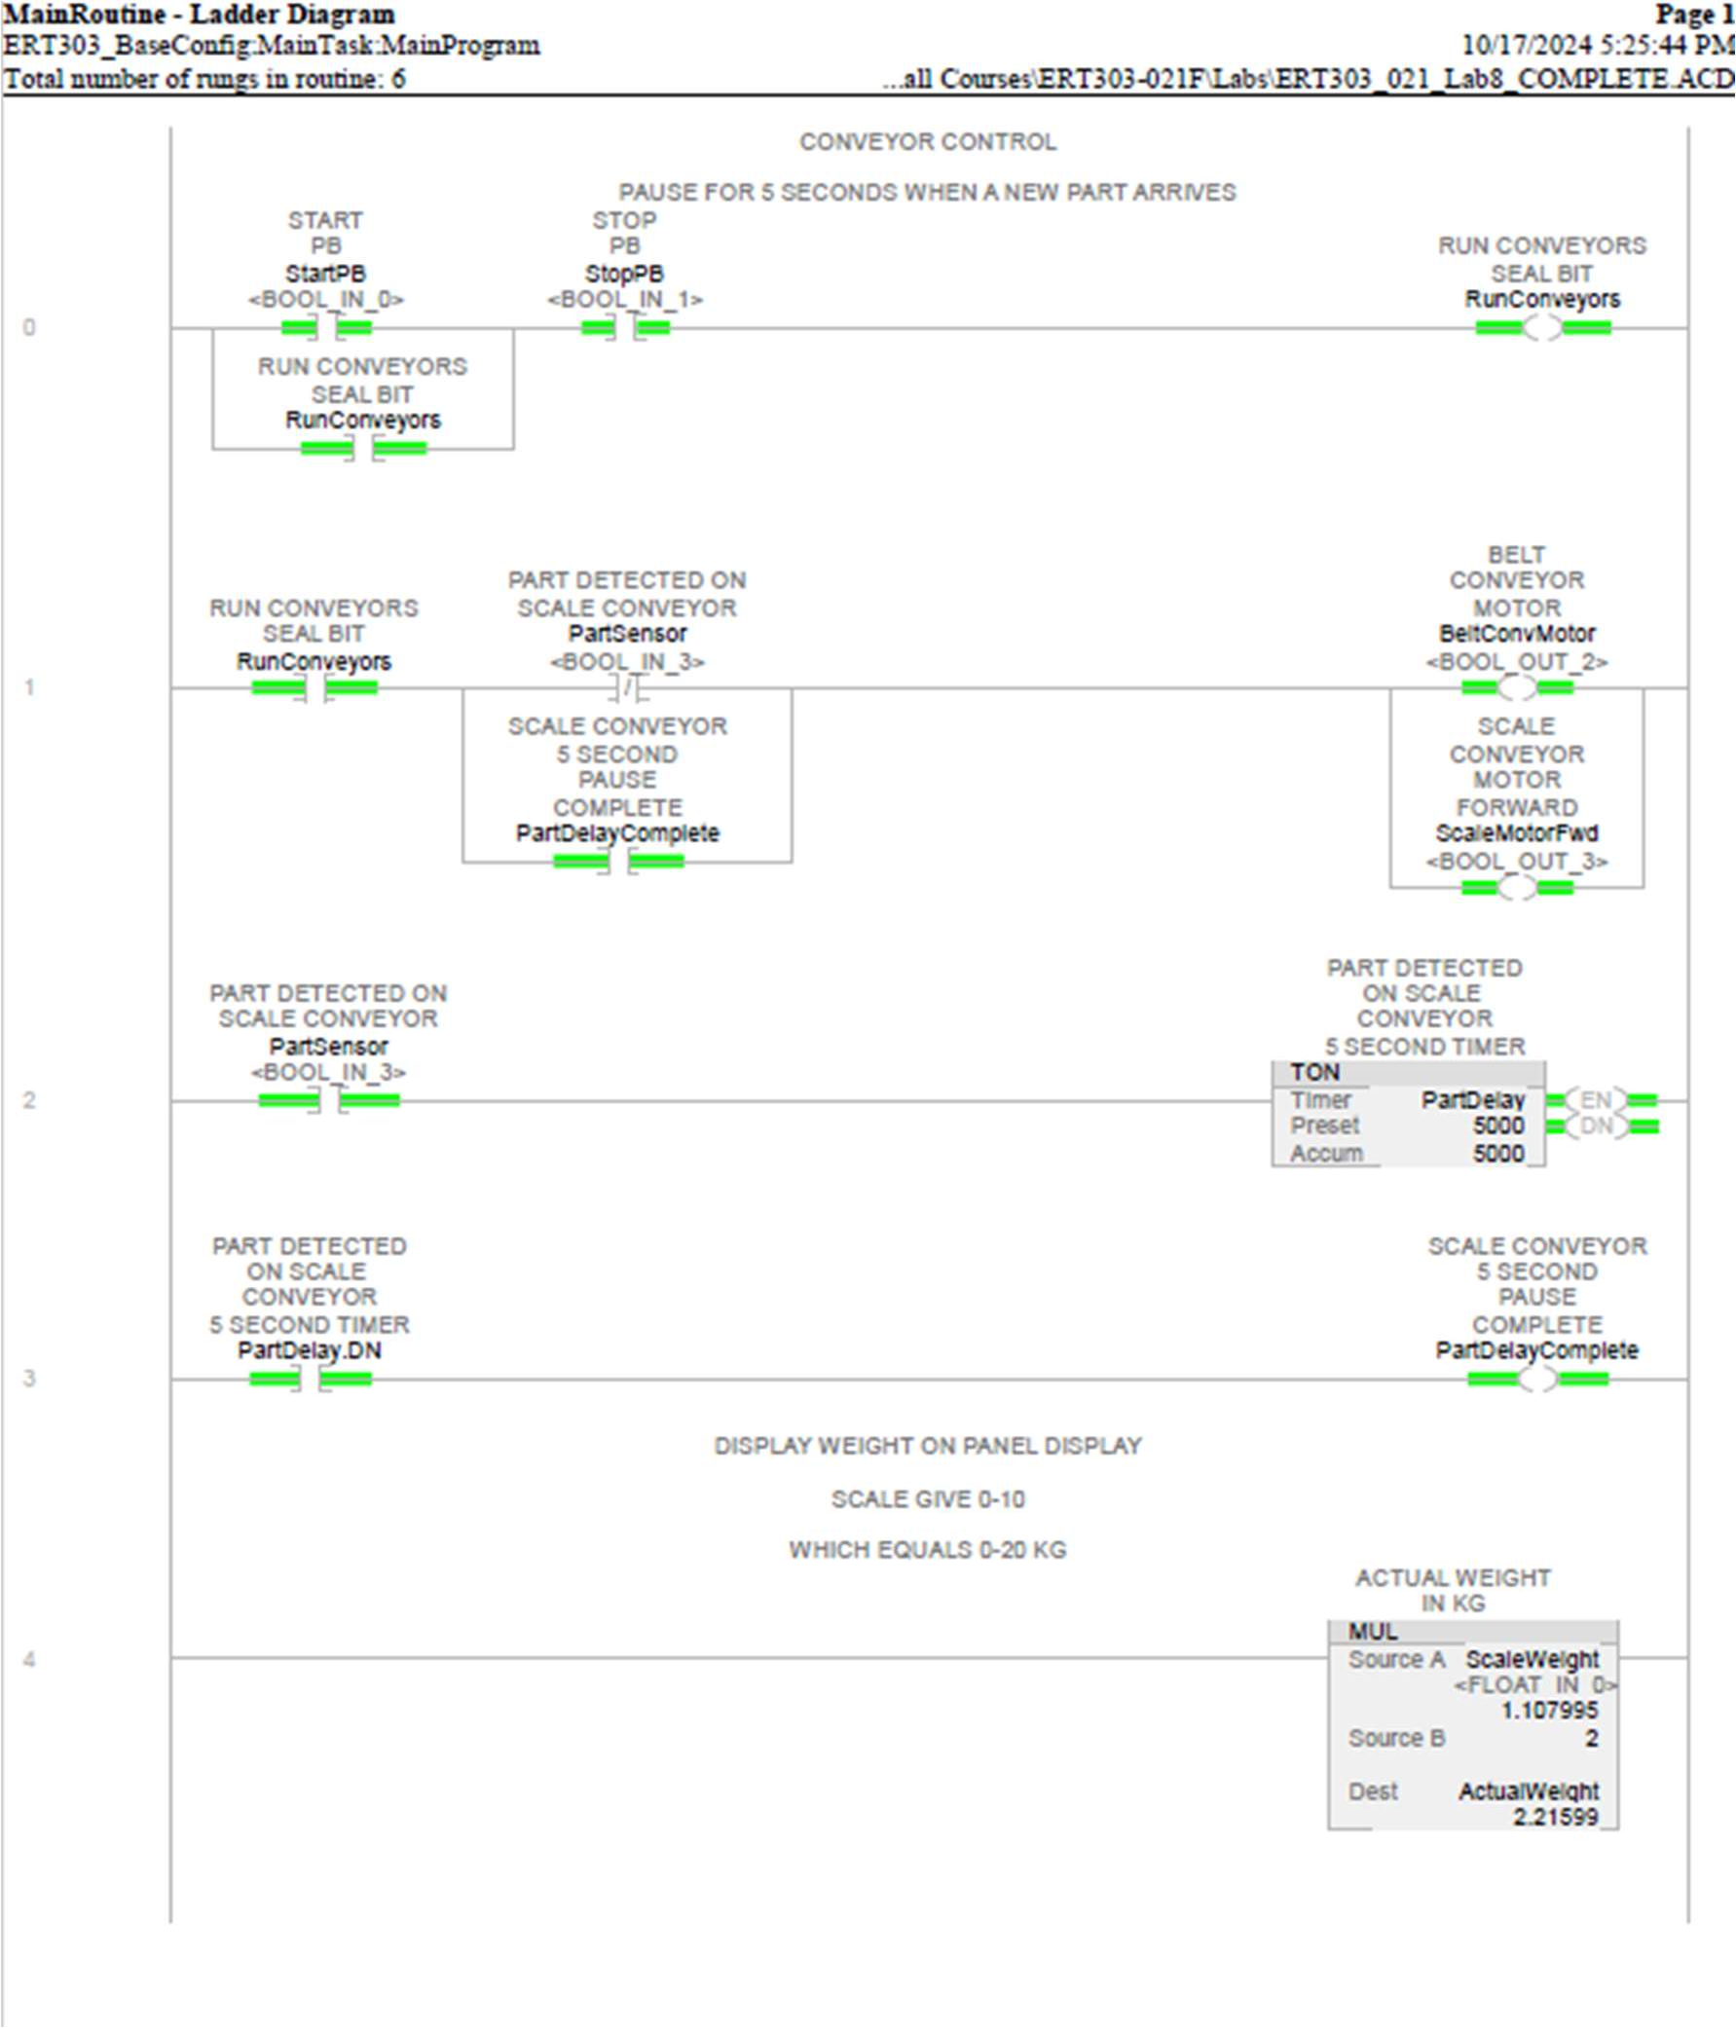

Figure 3 - Logic page 1

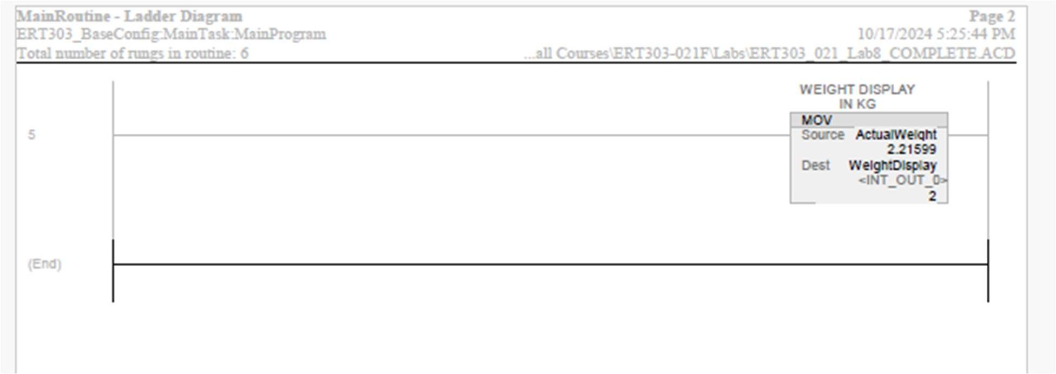

Figure 4 - Logic Page 2

